**Activity Space (Team development and Productive Meetings)**

**Recap:**

What was your key takeaway from the session on Strategic Presentations?

**Activity 1** – What makes a good team?

* What were the best teams you worked in?
* Why were they good?

Ideas:

* Clear Direction
* Team members are respectful and able to tolerate differences
* Time management (complete task on time)
* Give and receive feedback easily
* Team dynamics – Cooperation – working together
* Understanding strengths and weaknesses
* Finding a balance between work and play
* Communication
* Help each other with problems

**Activity 2**

* Can teams function well right from the start?
* What do you think are the stages of team development?

**Activity 3 – Reflection**

Think about:

* Your Working style
* Your commitment to the CS2113T project and OP1 project
* How you intend to contribute

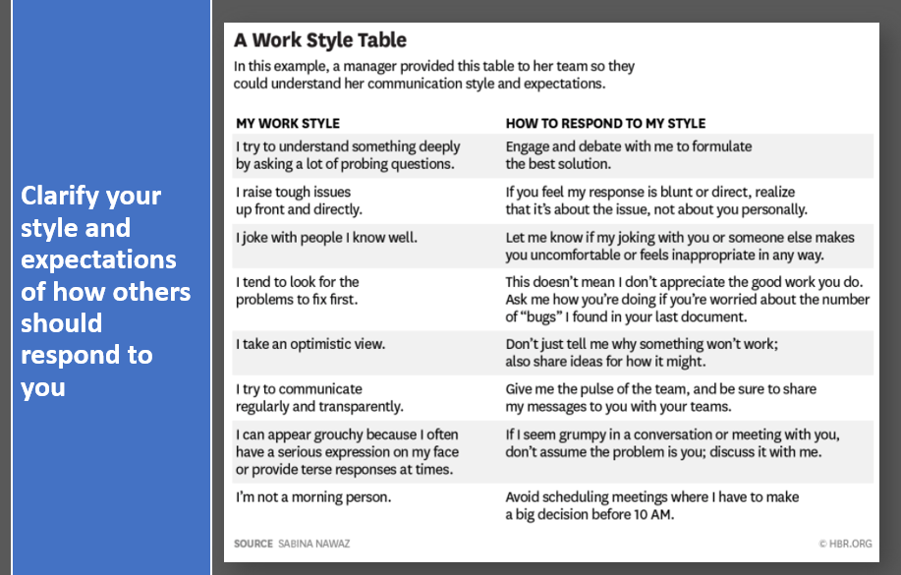

Let’s meet at 12.30

|  |  |
| --- | --- |
| **Name** | **Your working style,**  **level of commitment,**  **how you intend to contribute to your Project Team and OP1 team.** |
| Wraine | Working Style: I’m a morning person.  Level of Commitment: I tend to get things done and over with to relax as soon as possible. To just a level of satisfactory  How I intend to contribute: I go with the flow with others’ working style |
| Isaac | Working Style: I try to understand something deeply which might lead me to ask questions, someone who appreciates transparent communication, not a morning person...  Commitment and how I intend to contribute: Will definitely pull my on weight and do my part. |
| Musfirah | Working Style: Im not a morning person (but my brain can still work partially), I joke with people I know well, may be quite nitty gritty on details, will not leave your message hanging and replies very fast if im not busy. May need some reassurance sometimes also. Prefer technical/practical stuff over writing essays.... Also prefer to finish things fast so that I can rest more rather than completing them later near the deadline.  How i intend to contribute: I will do my part and if anyone needs help, I try my best to help. Sometimes, I may approach you if i feel that your work may need a bit of modification or could be improved. |
| Tai | Working Style: I will ask questions about the decisions we make not because I have something against you, but I want to understand why. I may not respond to texts very quickly, so give me a call if there’s anything urgent. I sometimes joke around, if it’s offensive please tell me. Do not like long meetings....short and quick would be better.  Level of commitment: I will contribute as much as I can, it may not be every day and usually happens in burst of times (procrastination...). I am taking a few other project heavy mods, so sometimes I need to rush the deadlines, hope you can understand!  How I intend to contribute: I will take up tasks that I feel is challenging, will give help to others if needed after finishing mine. Be sure to finish what is assigned and give feedbacks on other’s work. |
| Emily | Working Style: I tend to procrastinate but I follow deadlines given to me closely. A night owl hence can work till late night.  Level of commitment: Will contribute as much as I can.  Contribution: Finish the task assigned to me. Will help my peers if they reach out to me. |
| Daryl | Working style: I raise tough issues up front and directly, not a morning person, can appear grouchy sometimes but usually its just my expressionless face  Level of commitment: high, my workload is manageable for this sem  contribution: will put in time and effort on my part and help others if needed |
| Alan | Working Style: I can appear grouchy…; I try to communicate regularly…  Level of commitment: Will do my best to contribute as much as I can to the 2 modules, whilst allocating sufficient time to my other modules and non-academic obligations. |
| Braden | Working style: Not a morning person, might look at the problems first, but I value the team’s feelings too  Commitment level: I’ll do my part, try to balance things well, and will help out more if there’s a need to  Contribution: I plan to listen and respond well |
| Haziq | Working Style: I tend to focus on the big picture and how things flow before starting on my part on projects or discussions. Not a morning person, jokes a bit too much sometimes and tries to be optimistic.  Commitment Level: Will do what I need to do and help others if I can. Rather free but I tend to procrastinate |
| Sharif | Working Style: Like to debate on issues (play devil's advocate just to identify possible issues), hardly awake in the morning. I prefer working smart than to work hard, so I hardly grind for days on a single task.  Commitment level: Will put in as much effort placed for other modules, always aim for As lol mostly. Presentations are the fun parts of any project so i believe that it would be a fun project to engage in hence the level of commitment would be high. |
| Aileen | Working Style: I’m not a morning person. I take an optimistic view.  Commitment Level: High if I know how to do, but I overload (30MC) this sem, probably not reply immediately  Contribution: Can finish the work assigned to me |
| Shyun Yin | Working style: I take an optimistic view, I'm not a morning person, I try to understand something deeply by asking a lot of probing questions so I need my teammates to help to answer my questions and debate because I believe that only then will we settle on an idea that we all resonate with  Commitment level: I stay in hall and it is currently the busy period of competitions, therefore commit much currently. However from February onwards, I will only be left with 3 other activities outside of academics, therefore I will be willing to pour my nights into doing the project and learning stuff if needed to the best of my abilities.  Contribution: I intend to contribute to idea generation and learn from my teammates in order to help with coding as well. |
| Tuan | Working style: I am not a morning person, I tend to joke with people I know well, I take an optimistic view.  Commitment level: I will always try my best to finish my part of the project. I will try to help other people but only when I know that I am able to finish my work on time or have already finish my work. |
| Yu Zhong | Working Style: may raise tough issue upfront. I tend to look for problem to fix first, tried to communicate regularly and transparently.  Level of commitment: High. I will try to finish my part whenever i can. Will try to help one another if possible. I have 2 robot projects on hand from other modules.  Contribution: will work together, finish my part. |
| Jun Lim | Working Style: Also not a morning person, sometimes may be blunt when addressing any issues. Would prefer to communicate regularly and transparently Commitment level: I will contribute as much as I can since 2101 + 2113T is my first important module on SWE before I apply for internship. How can I contribute: I would like to first air out any concerns and find a general direction to how our team can go towards. Would also help out on areas where others are struggling with and encourage feedback whenever possible. |
| Haofeng | Working style: not morning person, can discuss until midnight. I joke with people I know ~~well~~. Commitment: I will finish the assigned parts before due date, but my time may be very tight as I have 6 projects this semester. Contribution: participate in the meetings and provide feedback. |
| Wei Li | Working style: Not a midnight (or later) person, prefer to work alone especially if workload has already been assigned and discussed. When discussing in teams, may be straightforward especially when deadline is near. Prefer to have many discussions and feedback from teammates when it's time to do so.  Commitment: I’ll straight up say that this semester I need to build two robots + CS2113T + CS2101 so things might get rough for me especially near the end and I’ll try my best. Looking for internship also that might take up some of my time.  Contribution: Gives my own idea, communicate my feedback, agreement and disagreement, work on the selected idea together. |
| Jun Leong | Work style; Target problems first, open but critical about proposed solutions until elaborated to seem to work. Commitment: average 5 hours a week idk, so long as we get the job done and not create the equivalent of Minecraft in Java. How to contribute: Establish solid enough groundwork first before coding the CS2113T product. Can’t really tolerate if suddenly want to change idea cuz of smth fundamentally flawed. |
| Edward | Working Style: I tend to throw out many solutions as a way to brainstorm and understand more about the project and our own ideas. These solutions honestly not meant to be taken seriously. Prefer to discuss big picture and leave the details to the end. Use of langugage might be bad but the bluntness is not an attack but cause of my poor language. Commitment is ok. |
| Anvitha | Working style: Im a night owl rather than a morning person, I tend to banter with people, I maybe a bad texter so sometimes if anything is urgent pls bump me.  I prefer to communicate with each other rather than face everything at the end.  Commitment: I stay in RC and am committed in my rc as well but i will make sure to carry my own weight but if anything needs to be done pls let me know early so that I have time to make changes. |

**How Google Builds the Perfect Team (Video)**

[How Google builds the perfect team](https://youtu.be/v2PaZ8Nl2T4)



* What are your key takeaways?
* How can we foster psychological safety in a team?

**Activity 4 – Team Forming & Norming**

In your project groups, please share:

* Your working style
* Your commitment to the group and project
* How you hope to contribute
* Any concerns you have

**Activity 5 - Team Forming & Norming**

In your OP1 groups, please share:

* Your working style
* Your commitment to the group and project
* How you hope to contribute
* Any concerns you have

**Activity 6 – Team Communication Scenarios**

**In your OP1 teams, please discuss the following scenarios**

|  |
| --- |
| **Team communication scenarios for discussion**  **Situation A: (Aileen)**  James has just formed a project team with 4 other students. As James engaged in his first discussion with his new team members, he realizes that the other 4 were already very familiar with each other as they had already worked on a couple of projects together in the past. James can see their camaraderie and is beginning to feel like an outsider to the team.   * How should James handle this situation? * What can/should the other 4 team members do to help James integrate into the team better?   **Ideas:**   * Make joke? Be open about his discomfort? Try to get to know others? * Get to know James; Invite him out for coffee; during meetings, ask him for his opinions * Establish a safe environment   **Situation B: (Group 1)**  There are 5 students in Samantha’s team. Every week, they each have to contribute one piece of work to the team project. If the team does not meet its weekly deadlines, the team does not get marks for that week.   * Unfortunately, 1 student in the team, Jan, has not been doing her part. The other 4 have at first covered for her because they did not want to lose their weekly marks. As the workload increased over the weeks, they found it increasingly difficult to cover for Jan, so they sat her down and talked to her about it. Jan assured them that she would do her part for the next week, but she doesn’t. They talk to her again. She assures them again that she would put in the work, but she doesn’t.   What should the team do now?  Talk to the prof/module coordinator as a team, just do their best to finish their own work while trying to split Jan’s workload among each other.  Ask the prof to take this into consideration and grade them separately.  Have a heart-to-heart talk with her (in-person) to find out what is going on.  **Situation C: (Group 2)**  Beatrice and her project team are meeting to discuss their team oral presentation, but they have encountered a roadblock. While Beatrice and Janice want to make the oral presentation as interactive and engaging as possible with Kahoots!, mini-games and prizes for the audience and not do a conventional (i.e. boring) presentation, Natalie and Valerie believe that they should stick to the conventional presentation approach and focus on strong content. They have spent an hour debating but have yet to reach a decision.   * What are your thoughts? Which type of presentation should they go with? What should they base their decision on? * They spent too long discussing on a plan.   The team should re-evaluate their presentation's context, purpose, and audience, and from there decide on which style of presentation (interactive or traditional) they should go with.  Should the team have sufficient time, perhaps they can formulate 2 mini-presentations, one interactive and one traditional, and see which presentation fits their purpose best. Should they still be unable to come to an agreement, perhaps they can consider compromising on a partial presentation (i.e. some elements of interactive and traditional combined).  **Situation D: (Group 3)**  Mark and his two teammates are meeting to discuss their oral presentation project for the first time. The three of them have not worked together before, and this is their first meeting. Twenty minutes into the meeting, Mark starts feeling frustrated because his teammates appear very quiet and do not seem to have an opinion about anything.`Mark, being a very vocal person himself, is wondering if his very quiet teammates are up to the task after all.  What is happening here?   * Why might the teammates seem quiet and non-committal? * What can Mark do to remedy the situation? What should he have done in the first place?  1. Social anxiety, don’t know what to say, nothing in common to talk about? 2. More introverted 3. No facilitator to help start ice breaking, ease the conversation 4. Maybe the teammates are tired and zoned out? 5. Maybe they are transferring out or going SEP and just heck care   ----   1. Mark can volunteer to become the facilitator of the group and prompt them with their input with regards to the project with open ended questions 2. Layout their working styles and personalities in the first meeting to understand how each of them are while working in a team and get rid of any misunderstanding that may arise as such.   **Situation E: (Group 4)**  Kendra and her team have been discussing their product demo for more than an hour now and are beginning to realize that they are getting nowhere because none of them have read their notes. They can’t decide on an angle for their presentation because they don’t know what kind of information is available to them. They decide to call it quits after one hour and a half, and to meet again after they’ve each read their notes.   * What should Kendra and her team have done to ensure that their meeting was productive? * Create a shared document with summarised notes, and every member should share what they think is important and have their own idea on what they want to present * They should have discussed the purpose of the meeting beforehand and ensured that everyone has done the necessary preparation * They should have started the meeting with reading the notes together to ensure that everyone is on the same page, which can be solved by having a meeting timeline * They could have done some goal setting for specific members to decide what they want to achieve during the meeting |

**Activity 7**

* OP1 Team Meeting Discussion – Agenda

**Instructions:**

* You can create a document in our shared folder - Week 3 - Agenda OR you can send your agenda to me via email (aileenteach@gmail.com) by (Thursday 27/1 2359).
* Discuss with your groupmates what you hope to achieve in 3.2 Team Meeting
* Choose topics that allow for more vibrant and insightful discussion; you may want to avoid discussing logistics or merely sharing what you have read
* Please note that you can continue your discussion after I observe you for 15 minutes so your points in your agenda can go beyond 15 minutes.

**CA1 Team Meeting Schedule**

Do join our zoom session at the timing assigned to you.

(*You can have your own zoom meetings before joining our session – If you happen to discuss the items already on your agenda before meeting me, that’s fine. Just let me know which other items you intend to discuss when you are with me).*

|  |  |
| --- | --- |
| **Time** | **Team** |
| 12.00 - 12.20 | 1 |
| 12.25 - 12.45 | 2 |
| 12.50 - 13.10 | 3 |
| 13.15 - 13.35 | 4 |

*(I’ll give some feedback after each session – approx 5 mins; Team 4 – we will end at 13.40)*